

DETAIL DESIGN

**Version1.2**

**Quốc Nhân**

**09/11/2019**

**VERSION HISTORY**

|  |  |  |  |  |  |
| --- | --- | --- | --- | --- | --- |
| **Version #** | **Implemented**  **By** | **Revision**  **Date** | **Approved**  **By** | **Approval**  **Date** | **Reason** |
| 1.0 | Quốc Nhân | 06/11/2019 |  |  | Create Document Detail Design version 1.0 |
| 1.1 | Quốc Nhân | 06/11/2019 |  |  | Update document detail design 1.1 |
| 1.2 | Quang Vuong | 09/11/2019 | Team | 09/11/2019 | Team review and update |
|  |  |  |  |  |  |

Table of Contents

1. Introduction 3

1.1 Purpose 3

1.2 Objects 4

1.3 Definitions, Acronyms and Abbreviations 4

2. Detail design 4

2.1 Purpose 4

2.2 Detail Design Process 5

2.2.1 Description 6

2.3 Role and Responsibility 7

**List of Table**

table : 1 Detail design process 4

# 

# Introduction

## Purpose

The document describes the work required to complete the detailed design phase of software products, including the main stages:

* Detail design phase

## ****Objects****

|  |  |  |
| --- | --- | --- |
| **No** | **Readers** | **Reason for reading** |
| 1 | Project manager | Capture the schedule of the architectural stages and update the plan of the project. |
| 2 | Mentor | Survey and guidance to develop detail design plans |
| 3 | Architecture & design leader | Use this document to manage and update the detail design progress schedule. |
| 4 | Architecture & design engineer | Read this document for a detailed design plan and follow-up plan to perform the work at this stage. |

## ****Definitions, Acronyms and Abbreviations****

|  |  |
| --- | --- |
| **Term or Acronym** | **Definition** |
| DL | Design Leader |
| AL | Architect Leader |
| SRS | Software Requirement Specification |
| SAD | Software Architecture Document |
| GUI | Graphic User Interface |
| DE | Design Engineer |
| SDS | Software Design Specification |

# Detail design

## Purpose

The process will define how to elicitation and analyze the detail design process, how to gathering the architecture, represent the resulting observations in adequate formats, and check the accuracy of the documents.

## ****Detail design process****

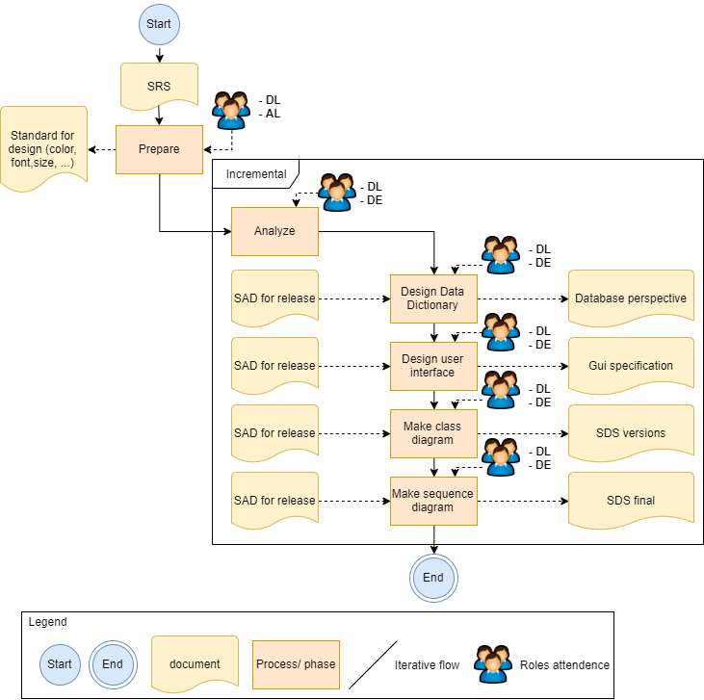

Table 1: Detail design process

## ****Description****

|  |  |  |  |  |  |
| --- | --- | --- | --- | --- | --- |
| **ID** | **Phases** | **Description** | **Input** | **Output** | **Role** |
| 01 | Prepare | * Defining design standards:   + The standards and conventions used during the architectural design phase are included in the detailed design phase. * Split the system into modules:   + Developers start with the main components defined in the SAD and continue to subdivide until the minimalist parts in the programming language. * Select and divide the divided sections from the above steps. | SRS | Standard | Design Leader & Architect Leader |
| 02 | Analysis | * After identifying the problem, the team will continue to analyze. * Need to find the cause of the error in step 1 because the software will have to run on any system. * Assure the quality of SAD content and information and understand them. | SRS, SAD for Release 1…n |  | Design Team |
| 03 | Design Data Dictionary | * Create database dictionary so that list the fields and data types in the database dictionary file. Based on the high level data type, the architecture design phase will divide and categorize the data information and determine the model for each type of data packet. | SAD document | Database perspective Document | Design Team |
| 04 | Define User interface | * Operates efficiently and controls well from system to end user * Create, design user interface (UI) to help users easily and effectively use. | SRS document | GUI specificationDocument | Design Team |
| 05 | Make Class diagram | * Create a static architecture diagram describing the system structure * Based on the granularity of each level from the preparation to create the class diagram. | SAD document | SDS Document | Design Team |
| 06 | Make Sequence diagram | Create an interactive diagram to show how to deal with other components.  Show object communication sequentially over time. | SAD document | SDS Document | Design Team |
| 07 | End | If the design meets the requirements, in accordance with the needs of use will move to the next step, if not reasonable to unify the idea to the design is more convenient and refined. |  | DBP  GUI  SDS Final |  |

## ****Role & responsibility****

|  |  |  |
| --- | --- | --- |
| **ID** | **Role** | **Responsibilities** |
| 1 | Project Manager | Collect, record all information, results, difficulties, solutions resolved among stakeholders. |
| 2 | Requirement Leader | Responsible for collecting and controlling requirements to assist the design team when needed. |
| 3 | Design Leader  Design Engineer | Responsible for design:   * Database Document * Document specification GUI * SDS Document |
| 4 | Architect Leader | Document support and product approval of the design team. |